16th October 2009
Rev. 11th May 2022

Issued by:

Ambient Pressure Diving Ltd
UK
Tel: 01326 563834
Email: info@apdiving.com

Care required when operating underwater hydraulic equipment, when diving with products fitted with Piezo switches.

Products affected: APD rebreathers with mono Vision controllers with Piezo switches:

Piezo switches are identified by their shape; a smooth round disc typically 20mm in diameter, which doesn’t appear to move when you press it

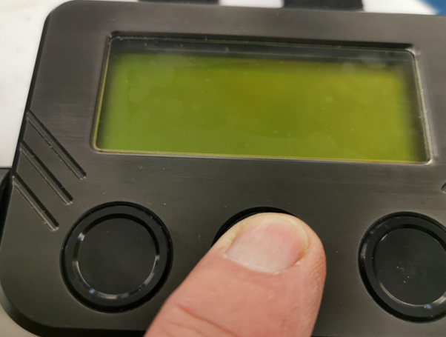

Note: Colour screen “Vision 2020” electronics are not affected as they don’t use piezo switches.

The mono handset Piezo switches have been replaced by a new spring loaded, push button, magnetic reed switches.

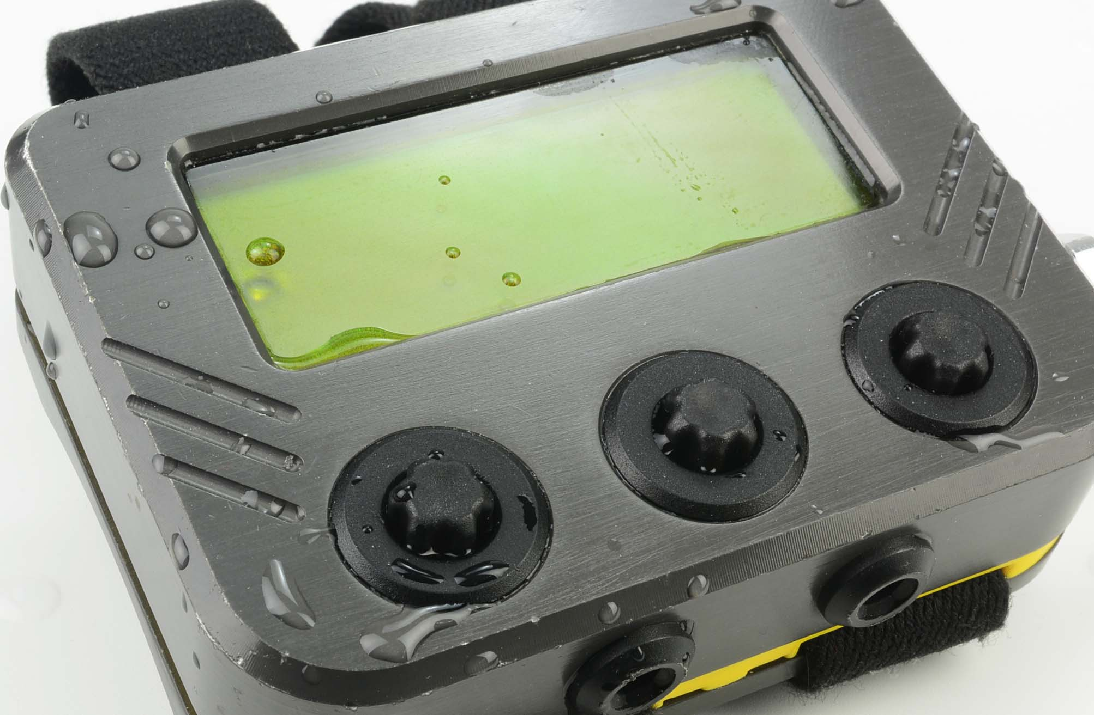
The product above is not affected in the same way.

It has been brought to our attention that when operating some hydraulic equipment underwater, there is a possibility of inadvertent, piezo button operation due to pulses of water directed at the handset and extra care must be taken to monitor the rebreather display at more frequent intervals.

Specifically, whilst assisting in the operation of a Jack hammer / road drill underwater, the percussion exhausts will have sufficient force, frequency and focus to press the piezo buttons when within 2 feet (60cm) and when facing the percussion exhausts.

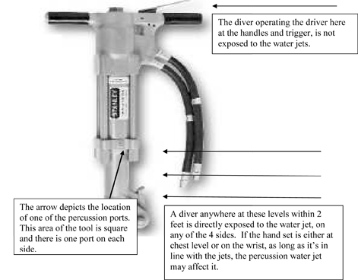

In tests, the button operation is random and this switching can cause a setpoint change or cause it to go in and out of OC mode and/or make any number of changes within the underwater menu including gas options, HUD brightness, LCD contrast, backlight, diluent gasses and bailout gasses. While either oxygen controller can be turned off and on, it is not possible to turn both oxygen controllers off simultaneously while deeper than 1.2m/4ft, providing there are two good batteries fitted or both batteries sufficiently charged.

We have been unable to reproduce the inadvertent button presses with normal diving applications. Tests include tap and fast water movement including moving handsets through water as fast as possible, diving in Rivers and tidal current, scootering, jump tests from various heights and various angles and we can state that inadvertent button pressing is highly unlikely. The fact is we didn’t get any inadvertent button presses in any of these tests.

Furthermore, this is not a problem for the diver holding the handles of the jack hammer, the problem exists for the diver assisting if he works lower down near the percussion exhausts.

Ambient Pressure Diving would like to take this opportunity to re-iterate to all rebreather divers the importance of looking at the PO2 displays regularly and draw your attention to the key waypoints during a dive where it is essential to monitor the PO2.

The following is extracted from the Inspiration user manual:

http://www.apdiving.com/en/wp-content/uploads/oxygen-danger-points-apdiving.pdf

